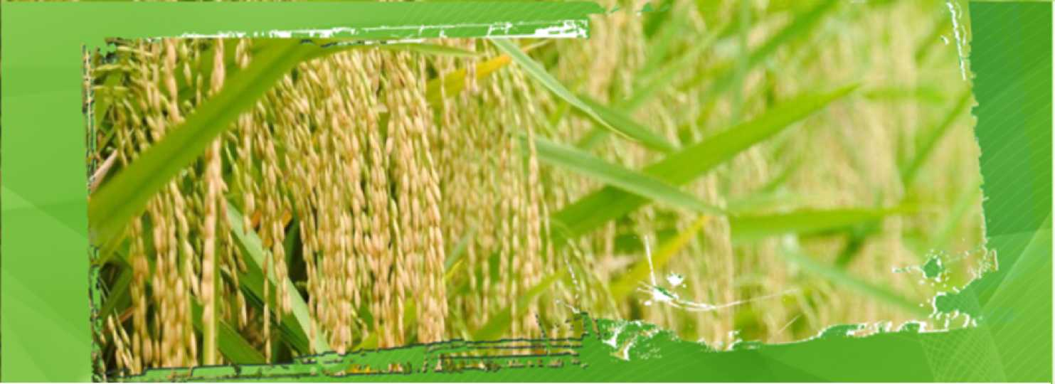

Hybrid Rice: Ensuring Food Security in Asia

Science For A Better Life
02.07.14, Bangkok
Frederic Top, Global Marketing Lead Bayer CropScience - Rice Seeds

Forward-Looking Statements

This presentation may contain forward-looking statements based on current assumptions and forecasts made by Bayer Group or subgroup management.
Various known and unknown risks, uncertainties and other factors could lead to material differences between the actual future results, financial situation, development or performance of the company and the estimates given here. These factors include those discussed in Bayer’s public reports which are available on the Bayer website at www.bayer.com.
The company assumes no liability whatsoever to update these forward-looking statements or to conform them to future events or developments.
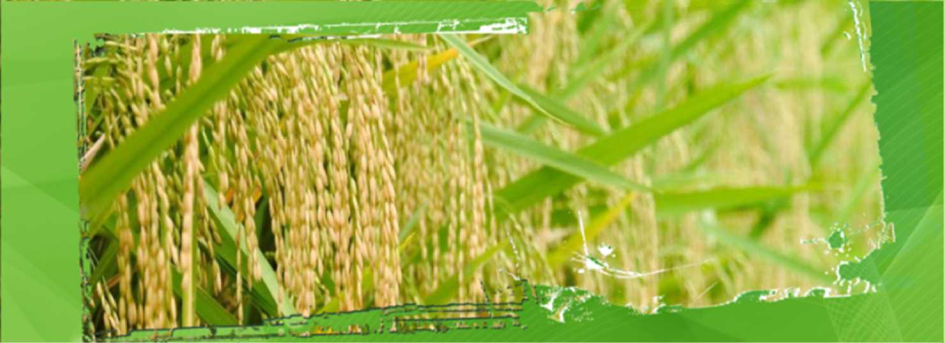
Content
The need for sustainable rice production The benefits of Hybrid Rice
Partnerships and Collaborations - Ways to accelerate Hybrid Rice adoption
Q & A
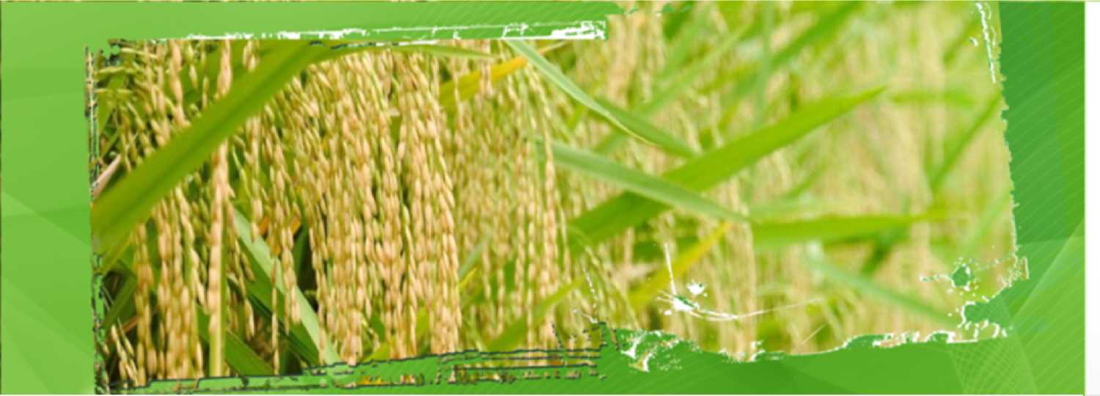
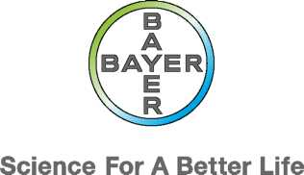
The need for sustainable rice production



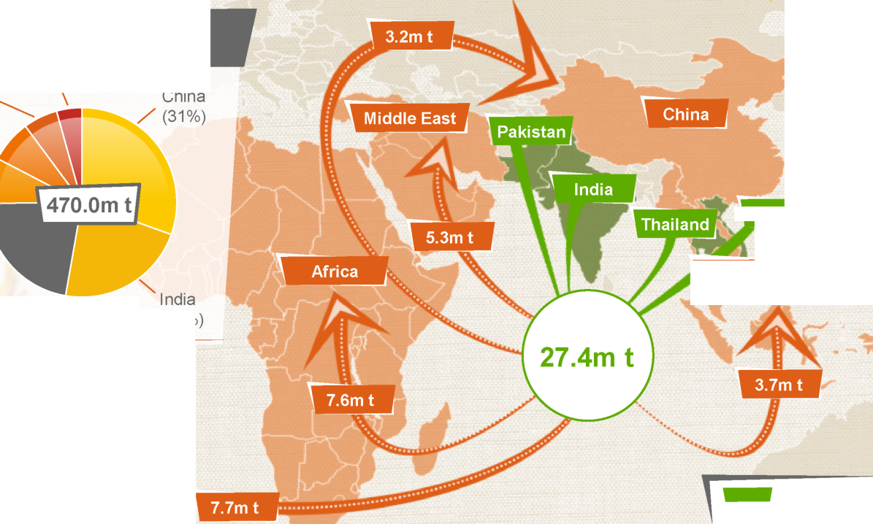
,'V / ■
y/ -'I ' B
mmm-’ ft / /
Ft K' \ i*. f w/ ^{J}
Vietnam
Indonesia/Malaysia/ , Philippines
Source: USDA (22%
Major Exporter Major Importer
Milled Production in 2012
Rice is the cornerstone of the Asian agriculture
- - ^ w, ■
«t 1 | Vietnam
«1 | (6%)
4 | Bangladesh
 | (7%)
 | Indonesia
- | (8%) —  I
1 | \  Others .
 | (22%)
A  à | Source: USDA

Vjft JUl
Bayer CropScience

Global trends impacting Rice farming
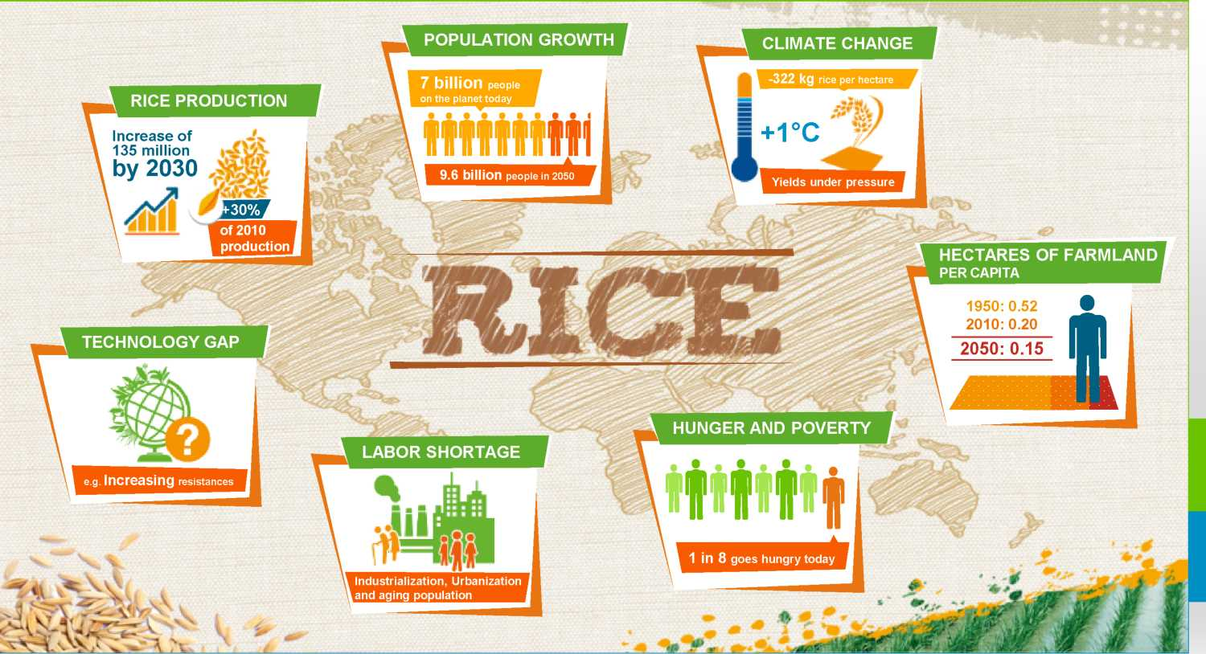

A growing threat: Climate Change

IPCC¹ actions for agriculture
1-Intergovernmental Panel on Climate Change

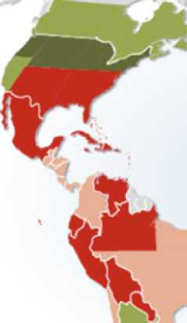
CLIMATE CHANGE 200Î
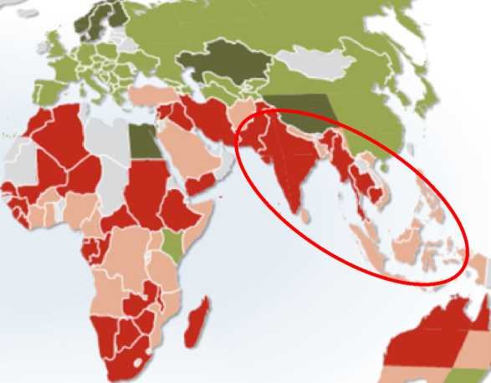
Projected change« ri agricultural productivity to £080 due to climate change, incorporating the effects of cartoon fertilisation -50« -15% 0 +15% +35% Mo data
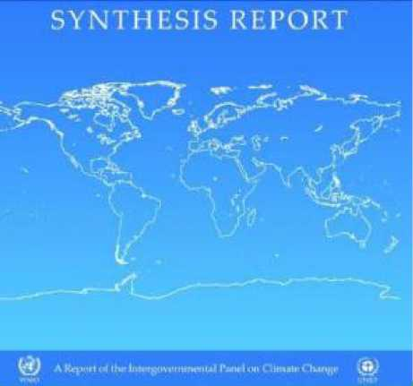

Key mitigation technologies and practices currently commercially available.
Sector
Improved crop and grazing land management to increase soil carbon storage; restoration of cultivated peaty soils and degraded lands; improved rice cultivation techniques and livestock and manure management to reduce CH₄ emissions; improved nitrogen fertiliser application techniques to reduce N₂O emissions; dedicated energy crops to replace fossil fuel use; improved energy efficiency; improvements of crop yields
Agriculture


Major effects of Climate Change for Rice
Higher concentration of CO₂ | © | (a priori favorable - up to a certain limit)
Higher temperatures | © | (bad for pollination and fertility)
More weather extremes | © | (irregular monsoon)
Change of water availability | © | (depleting water tables)
Degradation of soil | © | (salinization, leaching of minerals)
New pests, diseases and weeds | © | (Brown Plant Hopper...)
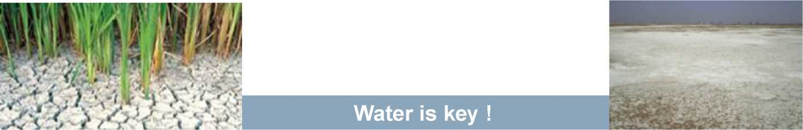


More productivity is needed, especially in Asia
Average Rice Yield in Major Rice Producing Countries
©Oryza
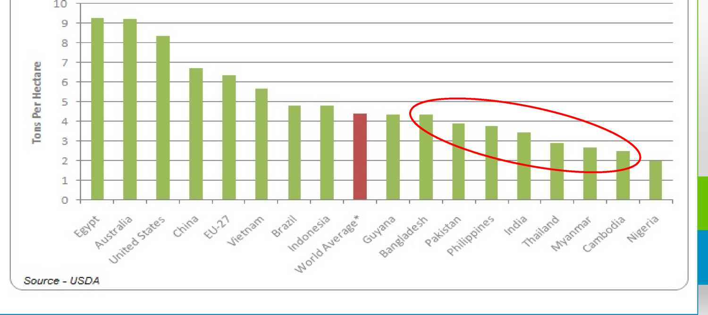
There will be the need to produce more rice in the future ^{BAYtK}

But current production growth rate won't suffice - example of India
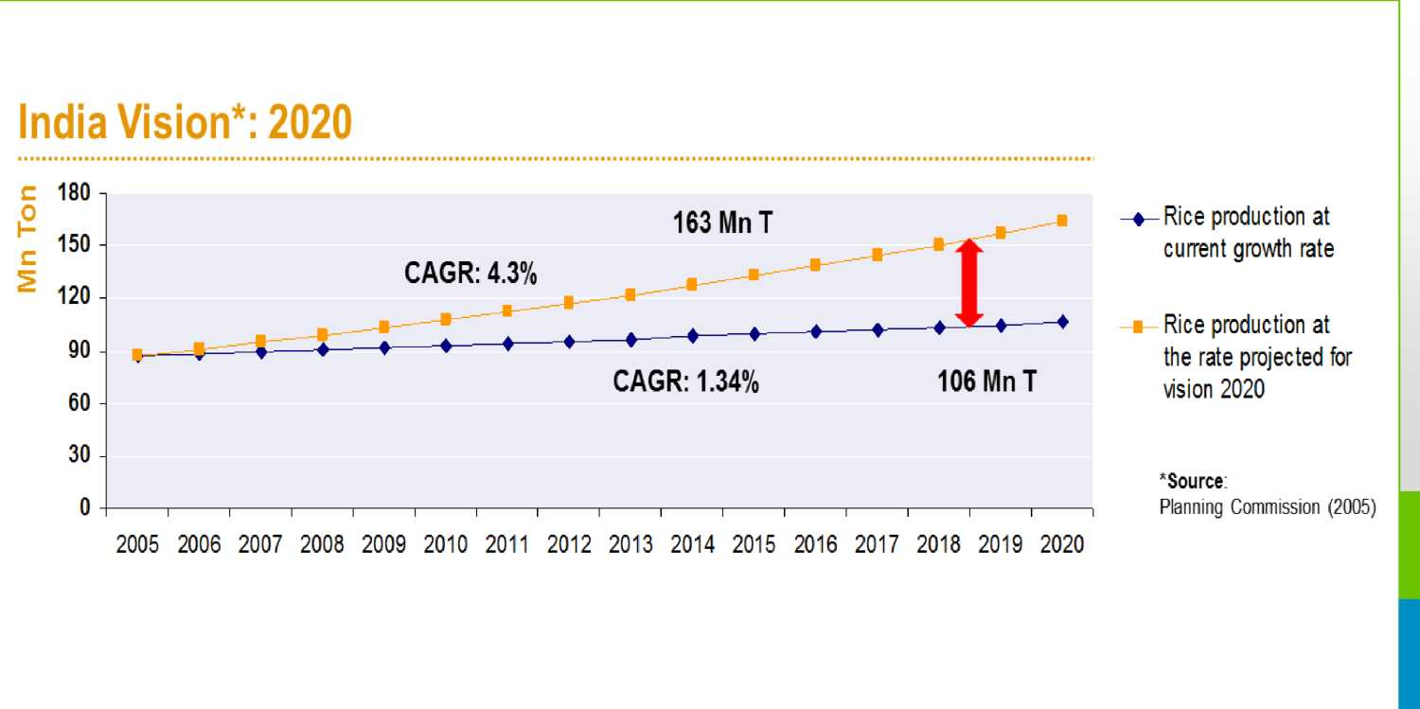
Efforts to break the current yield are plateauing
Government of India committed towards BGREI* with focus on Hybrid Rice Collaborations and partnerships are encouraged
* BGREI - Bringing Green Revolution in Eastern India

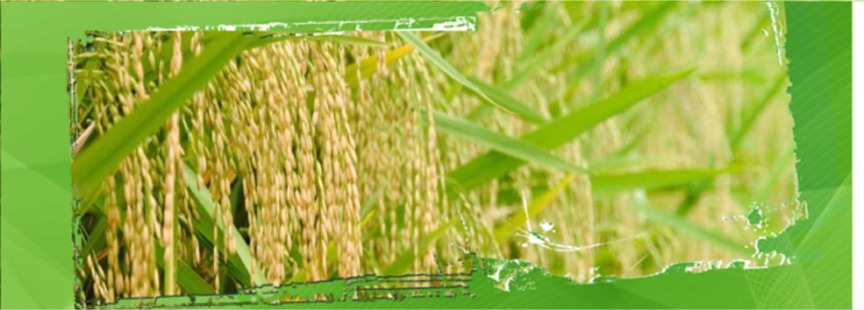

The benefits of Hybrid Rice
Science For A Better Life
I

Hybrid Rice _{A}
is the result of the cross of 2 different inbred rice parental lines bayer
The increased yield in F1 generation is due to a phenomenon called heterosis

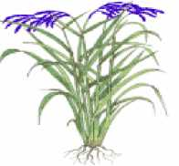
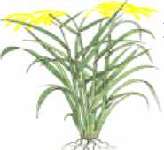
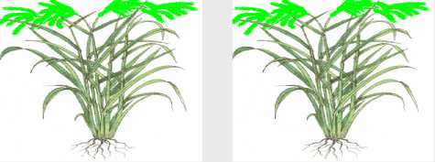
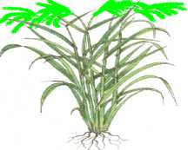

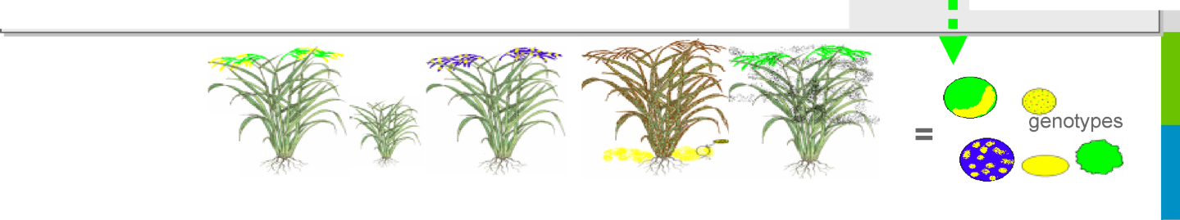
\ !/.. ''i ■¹ ■ ■
: ;' >■■ ■; f-:.-, v"'"'^{L}-' '' ■'
<** Cross pollination
Female parent
- No pollen
- Produces hybrid seed
genotype.)
Male parent
• supplies pollen
Creation of Hybrid Seed
\ ♦,
Yield Potential 6 t/ ha
Yield Potential 5 t/ ha
Hybrid Rice
(F1 - first generation)
- Every plant genetically identical
- High yielding - Highly uniform
genotype
Yield Potential 8 t/ ha
Same Hybrid Seed is replanted
Hybrid Rice
(F2 - 2nd generation)
- Every plant a different genotype
- Highly variable populations
Yield Potential app 6.5 t/ ha
but variability - different harvest times - may bring it <6 t/ ha

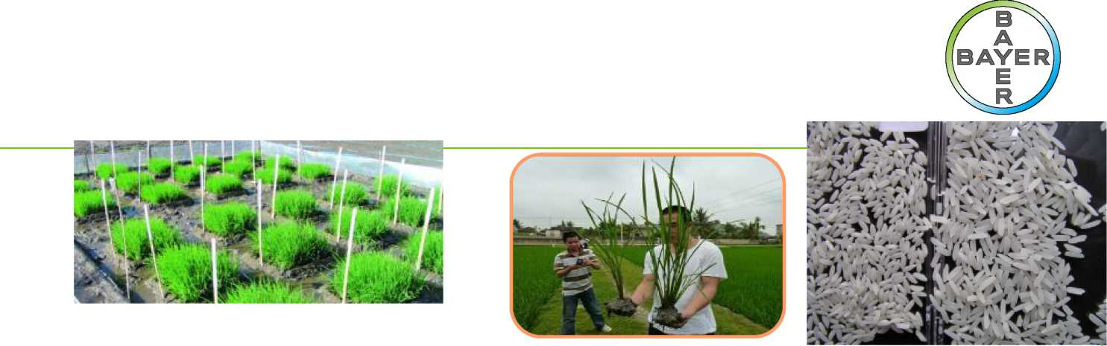
Hybrid rice
for sustainable Higher Yield

Hybrid Rice contribution to sustainability:
- Higher yields => more income for the farmer
Increased average yield of Arize® hybrid rice seed
(On-farm results in India)

- IVIUIC IC3IIICIIUC IU CIUIULI^ 31IC33C3.  ■ Temporary drought or flood |  | > 20 % | I I
■ Moderate salinity |  |  | íÁrize
=> Suitability for Direct-Seeding | In-bred  lines |  | íÁrize
■ Better CO₂ sequestration (increased biomass) | In-bred  lines
Better nitrogen use efficiency
Hybrid cultivation is certainly the most sustainable rice production system

// ¹ \

Hybrid Rice has a better ROI than inbreds bayer
India - Transplanted - Wet season 2008 ^{R} '

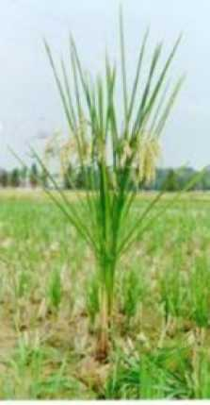
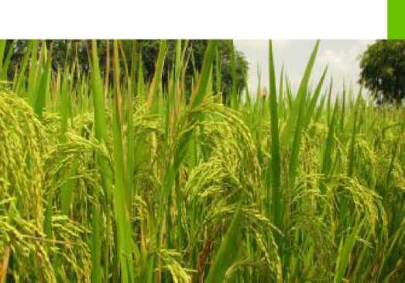
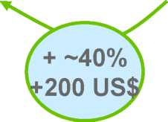
In IND Rs | Arize® 6444 | Sarju-52
Seed | C3,000 ) | 750
Fertilizer | 1,210 | 1,350
Crop protection | 1,750 | 1,750
Labor + Mechanical costs | 8,500 | 8,000
Irrigation/Water management | 4,000 | 4,000
Total Cost | 18,460 | 15,850
Yield (kg/ha) | C7,250 ) | 5,500
Total Income | 61,625 | 46,750
Net Income | 43,165 | 30,900
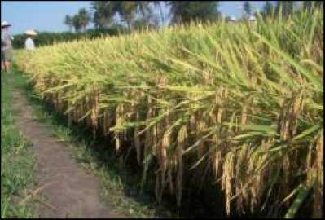

Hybrid Rice has a good Water Use Efficiency

Example of Arize 6129 in India - Punjab University 2009-2011

Water Use Efficiency (kg/ha.cm)
Yield (T/ha)

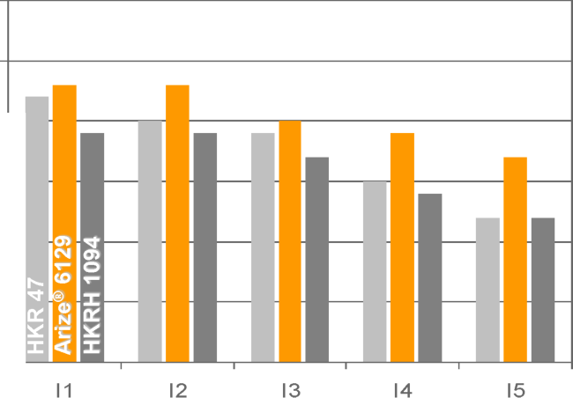
! as
ii- 5 °
© x
I* a *
■ ^ -C * |x < X
I1
8,0
7.5
- —
- —
- —
- —
5,0 —
50 - 45 - 40 - 35 - 30 - 25 - 20 - 15 - 10 - 5 0 -
I2
I3
I4
I5

I1: Continuous submergence throughout crop season
I2: Continuous submergence up to 14 days after transplanting, then irrigation 1 day after disappearance of ponded water
I3: Continuous submergence up to 14 days after transplanting, then irrigation 2 days after disappearance of ponded water
I4: Continuous submergence up to 14 days after transplanting, then irrigation 3 days after disappearance of ponded water up to 55 DAT, then submergence for 1 week and then irrigation 2 days after disappearance of ponded water
I5: Continuous submergence up to 14 days after transplanting, then irrigation three days after disappearance of ponded water


Hybrid Rice: a vehicle for interesting native Traits

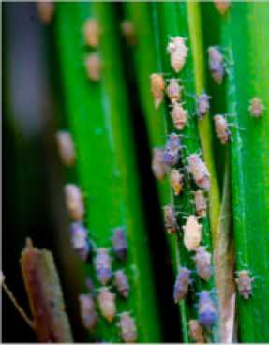
Brown Plant
Hopper
tolerance
Salinity &
Submergence
tolerance
Bacterial Leaf Blight resistance
Blast tolerance
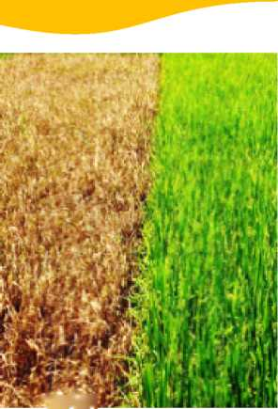
fiufln
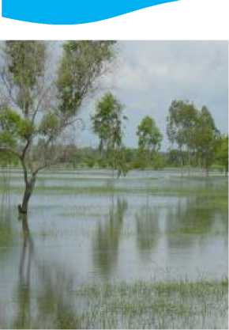
(2016 - 2019)
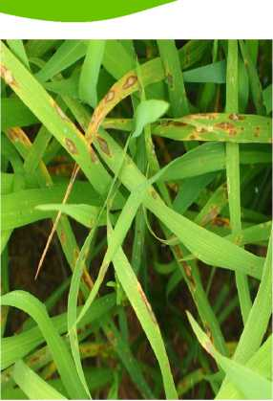
(2013 - 2017)
(2008 - 2014)
Opening wet season for Hybrids in the PHL and BAN
(2014 - 2018)
A first line of defense against this unpredictable pest
A new tool to fight the most noxious disease of rice
Reclaiming land lost because of these abiotic stresses

Hybrids play an important role in shaping a sustainable rice production
Sustainable Rice Production

Economy
Society
Ecology

■
■
■
- Yield security & increased productivity
- Secured income of
smallholder farmers
- Reduce imports, enable exports
- Innovative solutions & technology transfer
- Adaptation to climate change
- GHG Mitigation
- Increased water efficiency
- More resilience to pests and diseases
Food security & safety
Livelihood & rural development: avoid rural exodus, allows education
Improves labor conditions

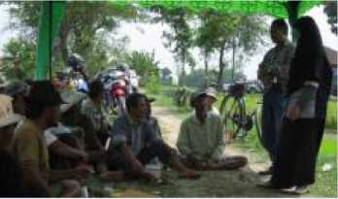
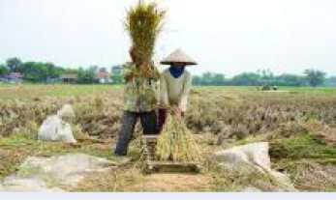


Sustainable intensification of rice production requires sound partnerships

Partnerships and Collaborations - Ways to accelerate Hybrid Rice adoption
Science For A Better Life

Hybrid Rice Acreage Development

*Current Hybrid Rice markets in Asia (excl. China): India, VietNam, the Philippines, Indonesia, Pakistan, Bangladesh

It is possible to grow Hybridization to 14% by 2022 (in current countries) But Hybrid Rice adoption has to accelerate if we want to achieve 30% more rice by 2030 (vs 2010)
Not only in current countries but also in new ones
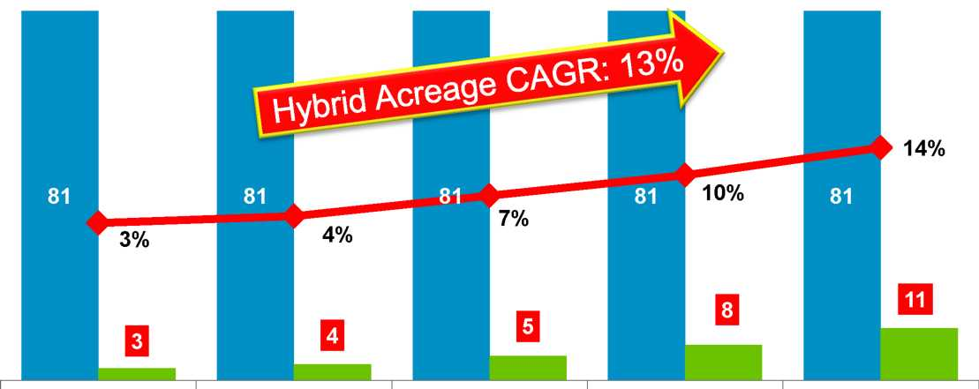
Mio ha
2010 A
2013 A
2016 F
2019 F
2022 F
Total Rice Area
Hybrid Rice Area
% Hybrid Rice

Sustainable rice production requires sound partnerships
- To produce rice sustainably, farmers need to have broad access to:
appropriate innovations, and the knowledge and skills to value these tools on the farm.
- We support the development of PPPs as a key mechanism to develop and deliver the hybrid technology in the face of changing demands
- Collaborative partnerships can effectively bridge the gap between public and private sectors' distinctive competencies for efficient and sustainable rice production
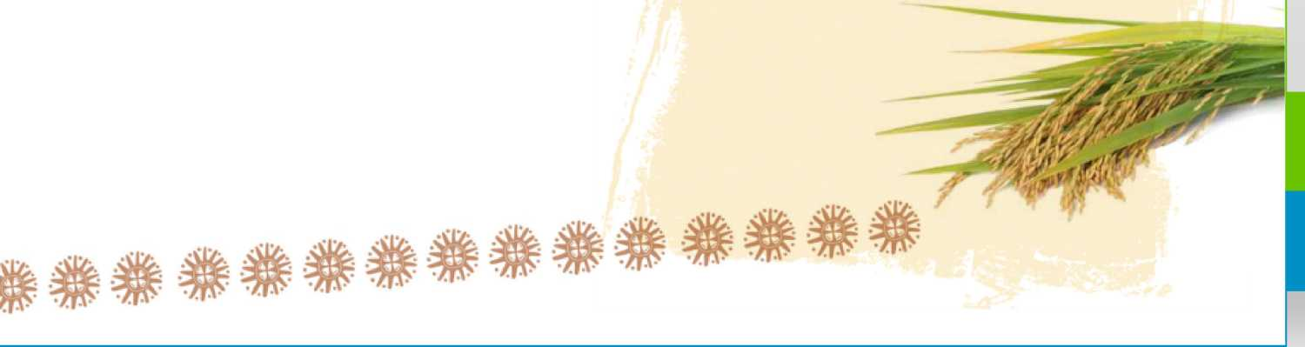

The private sector values and fosters partnerships
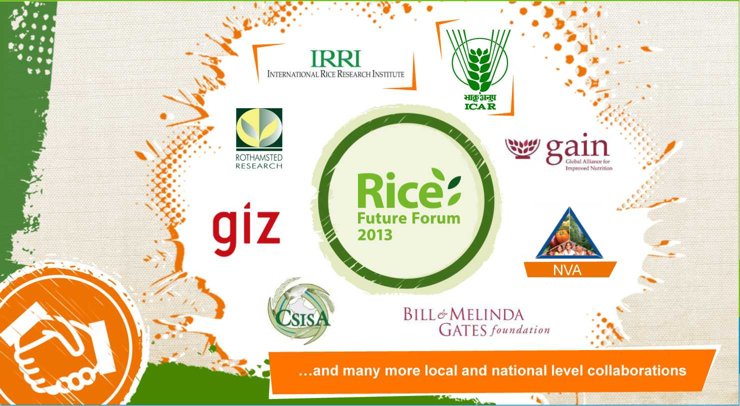

The role of the private sector

Develop hybrids with a broader genetic diversity.
Provide extensive farmers’ training to allow a fair adoption of the technology.
Strengthen and empower the local communities to :
Ensure food security for the family,
Keep farming attractive and economical : avoid rural exodus, Generate employment: production of hybrid seeds.
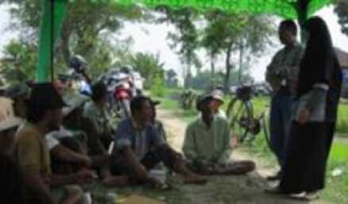

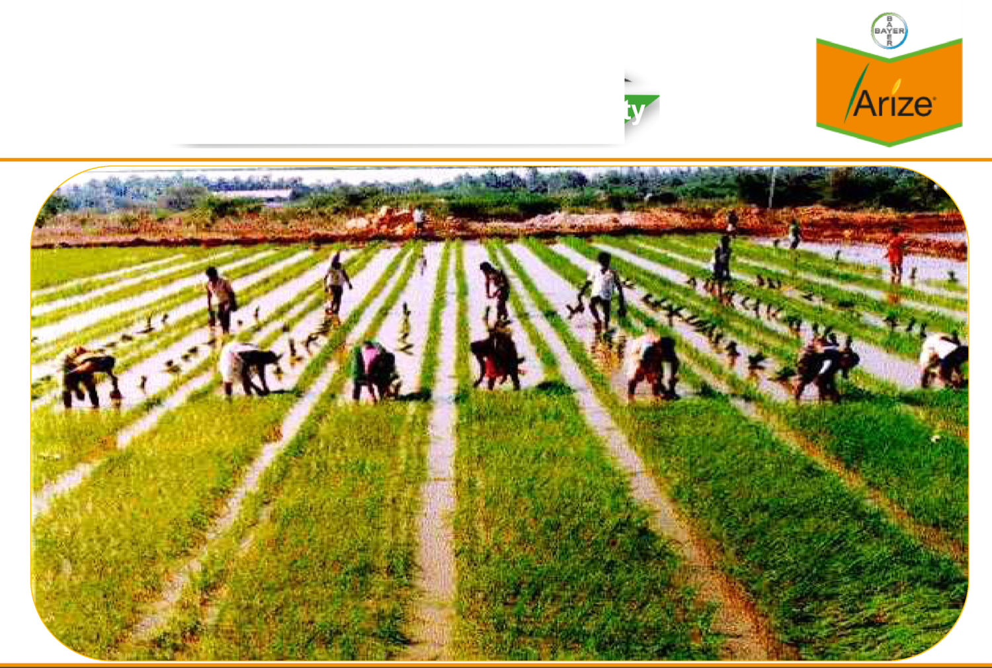
HR Seeds production
Giving employment to the communii
Better Rice Better Life
Page 23
H Ujyer Crop Science

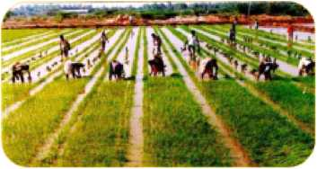
Hybrid Rice production: _{B}J_{ER} the need for sound country regulations y

The role of the public sector (1)
Set up adequate mechanisms for allowing a free movement of seed material for hybrid development and sales:
separate from food or grain security,
for development but as well sales before the hybrid is produced locally, while ensuring protection of intellectual property rights.
Facilitate PPPs to research, develop, commercialize and promote new solutions: encourage the introduction of innovative and sustainable solutions, harmonize and implement science-based regulatory systems in each country, provide training to facilitate the development of modern farming.


The role of the public sector (2)
Organize appropriate financing systems to allow farmers to access credit.
Improve links between farmers and millers.
Build and maintain roads and storage facilities to enhance the movement of food and significantly decrease post-harvest losses.
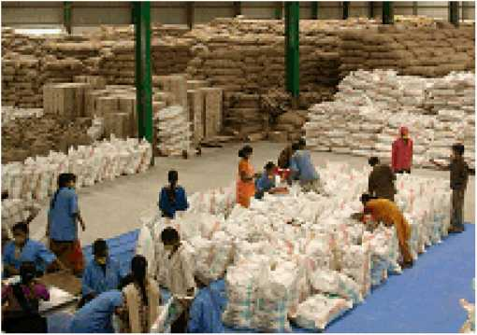

An example of partnership in the Philippines: DA allots P550M for hybrid rice seeds
P550-million rice sufficiency program announced in June 2014.
DA will buy farmers’ hybrid rice seeds for planting in the dry season 2014-2015.
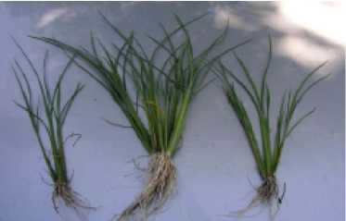
Private companies are committed to expand their seed sales to 200,000 hectares.
Government’s support to private companies will be in the form of: information campaign on the use of hybrid rice seeds, technology demonstration farms for hybrid rice.
Each farmer will only receive DA’s support once:
“We want farmers who have not yet tried planting hybrid rice to try it once and realize an improvement in his yield. Once he realizes a better income from hybrid rice, we expect farmers to be capable of buying their own seeds next time”.

Some other examples of Private-Public Partnerships in Rice in Asia
- Cereal Systems Initiative for South Asia (CSISA), with CIMMYT and IRRI
- Hybrid Rice Development consortium (exchange of germplasm), with IRRI
- Proposed Indian Hybrid Rice Consortium, with ICAR and many other partners
- Consortium for the Ecological Intensification of Rice Systems (CEIRS), with IRRI
- Sustainable Rice Platform (SRP), with UNEP, IRRI and many other partners
- Better Rice Initiative in Asia (BRIA), with GIZ

Partnership for sustainable rice production
Cereal Systems Initiative for South Asia (CSISA)
Working together with extension services to promote good agricultural practices
Providing high quality, diverse and healthy food in sufficient quantities Establishing knowledge and technology transfer
Improving farmers’ livelihood and driving rural development
(education, best practice sharing)
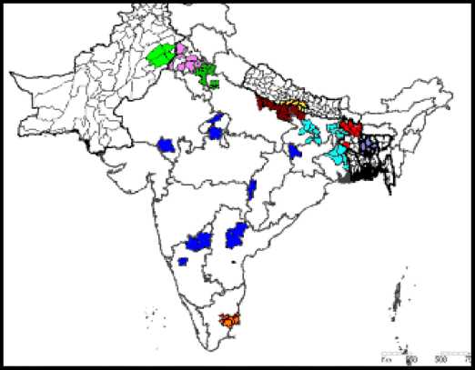
Improving labor conditions
India and Pakistan: collaboration with CYMMIT and IRRI on Direct-Seeded Rice & Hybrid Rice development
- Minimum soil disturbance / Soil cover / Crop rotations
- Nutrient management & GHG measurements
- Hybrid Rice demonstration field trials
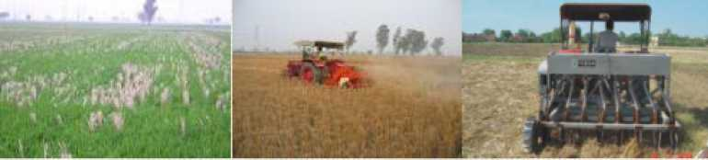
Hub locations in 7 States (Punjab, Haryana, Uttar Pradesh, Bihar, West Bengal, Tamil Nadu, Karnataka)
Consortium for Ecological Intensification of Rice Systems (CEIRS)
GRiSP Product Line 3.1. Future management systems
Observation Researchers
Note
The contents of this page are based on Principal Investigator's report dated 16 May 2012

Site Name
AsiaFlux Site Code
Location
Position
Elevation
Slope
Terrain Type Area
IRRI Flux Research Site IRI
IRRI. Los Banos. Laguna. Philippines 14.2"N, 121.3°E 21 m above sea level 1-2"
Fiat

Develop and assess innovative Rice production systems based on the principles of ecological intensification (at least the same yield while using less water, less
manpower and emitting less methane)
//
First results indicate Hybrid Rice fits very well in these systems
Page 30

Sustainable Rice Platform (SRP)

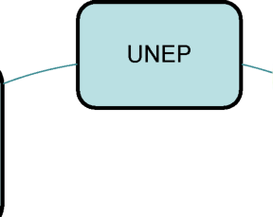
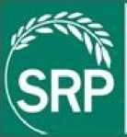
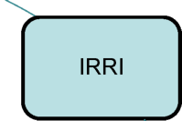

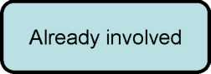
\gt
UNEP
Governments
- Thailand
- Vietnam
- Laos ?
GIZ
Sustainable
Rice
Platform
Certification Agency: UTZ
Being recruited
V'
Source: IRRI
Environmental and social NGOs
Goal:
To promote resource efficiency and sustainability in the global rice sector through an alliance that links research, production, policy making, trade and consumption
Private Sector Input suppliers: Bayer Rice product manufacturers: Kellogg, Mars
Traders: Louis Dreyfus, OLAM Retailers: Ahold Finance: IFC
/■ | \
Research
• CIRAD
• Universities:
Punjab...
V | J
IRRI
Consumer
Groups

Conclusion Invest in hybrids for ensuring food security
Hybrid rice is an innovation that can feed Asia’s growing population sustainably.
The private sector is committed to commercializing hybrid rice in various countries:
already in India, the Philippines, Vietnam, Pakistan, Bangladesh and Indonesia tomorrow certainly in Malaysia, Thailand, Cambodia or Myanmar.
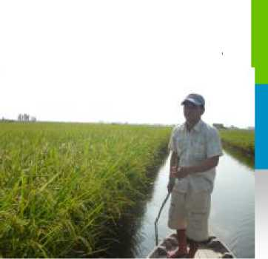
However the adoption of hybrid rice requires considerable efforts.
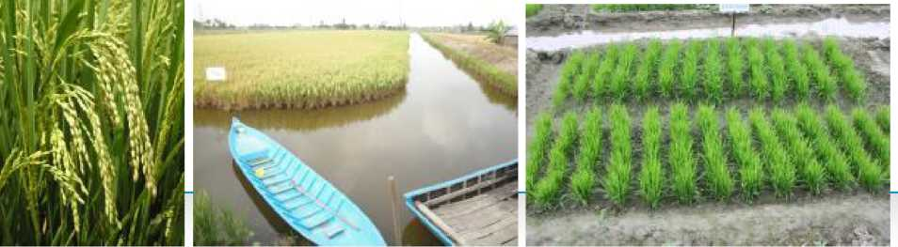
The many stakeholders involved must all work together to create an enabling environment to support the adoption of by the rice farmers and their communities.


IT f
if

.> i - ¿r
Let’s join forces and work together
to drive the adoption of hybrid rice




Q & A

Science For A Better Life

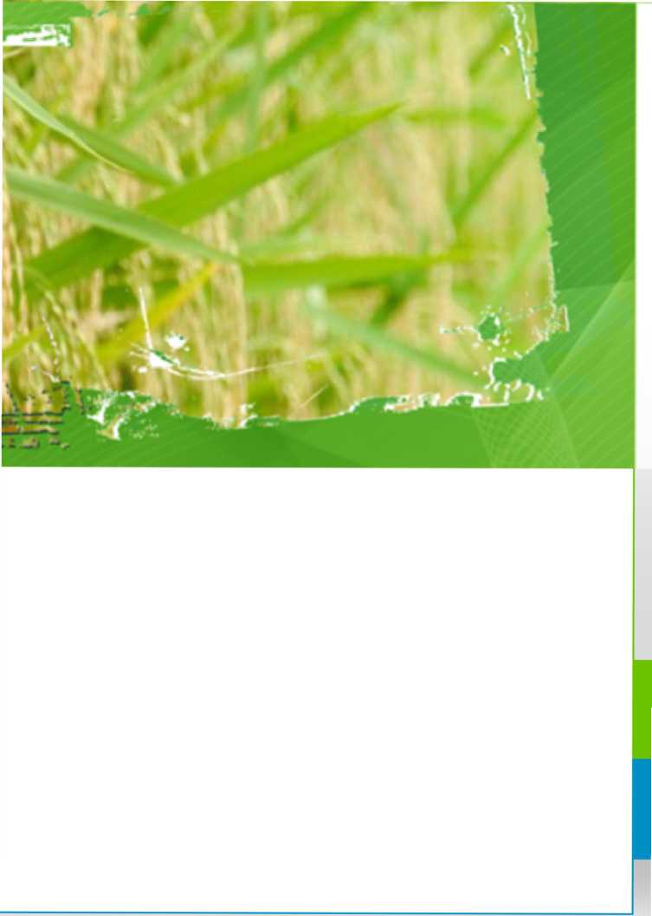
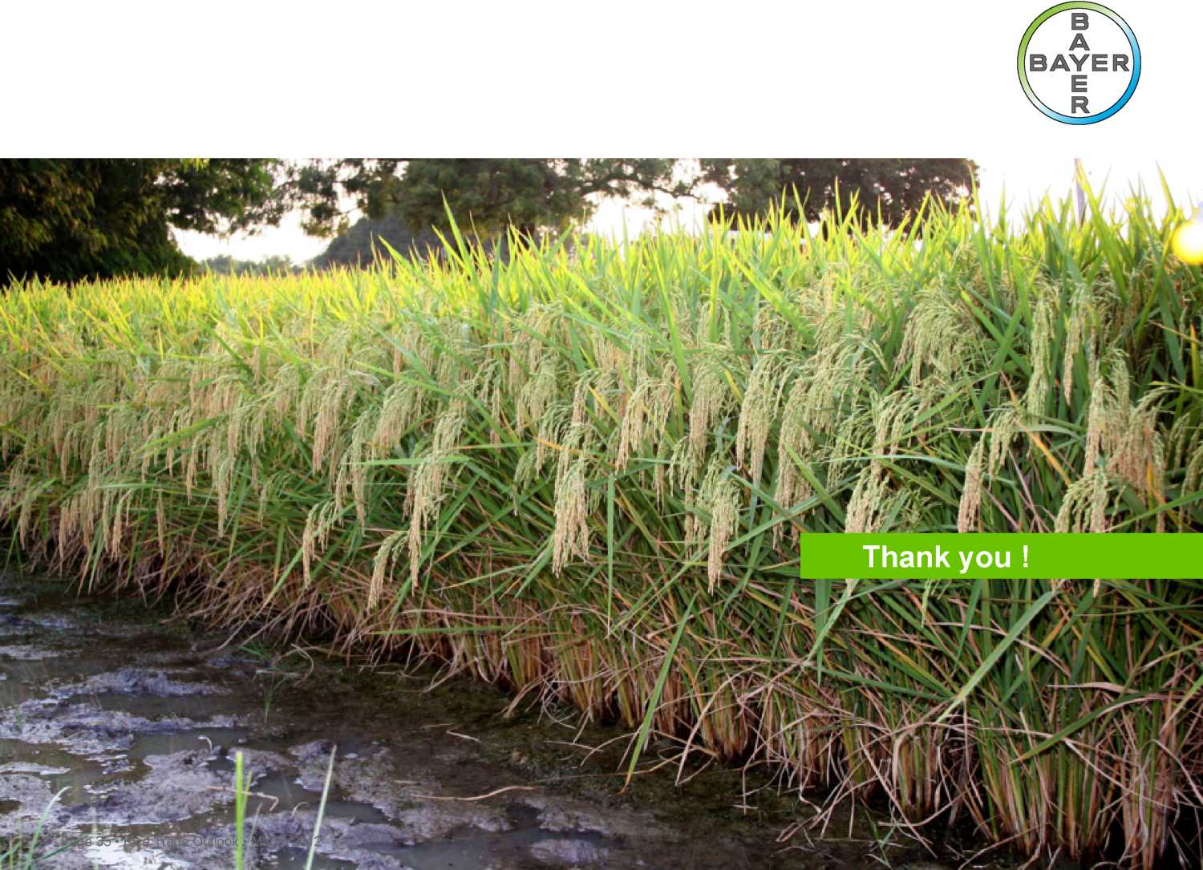

- Complexity of Hybrid Rice production.
- Several years needed before being able to deliver reliable volumes.

Countries where Hybrid Rice has been successfully developed have followed these steps: - Test various hybrids locally to determine which the most adapted are for registration - Once registered, allow the import of the selected hybrid seeds in bulk for commercialization during a good number of years, without limiting their import - In parallel, during these years, test the production of these hybrid seeds by allowing the import of the parental lines for the tests (3 to 5 years) - Once the produce-ability of the hybrid is OK, produce the hybrids seeds locally - Therefore sound regulations are needed to permit a smooth flow of seeds between countries.

